**ALAGAPPA COLLEGE OF TECHNOLOGY**

**ANNA UNIVERSITY-600025**

**NAAN MUDHALVAN ASSIGNMENT**

**DIGITAL MARKETING**

**Name:** Nehasri S R

**Roll No:** 2020308025

**Department:** B. Tech Pharmaceutical Technology

**College:** Alagappa College of Technology, Anna University.

**Naan Mudhalvan ID:** CEB82A0395F1B0DB9FF4AE00B6D35FE3

**Zone:** Zone-1

**Assignment-1:**

Create a company name and design a poster and logo for that company.

Company Name: SUSH STYLISH BRIDES

Company Type: Garments

Logo:



Poster:



**Assignment-2:**

Create a blog describing your company.

Blog Link: <https://sushstylishbride.blogspot.com/>

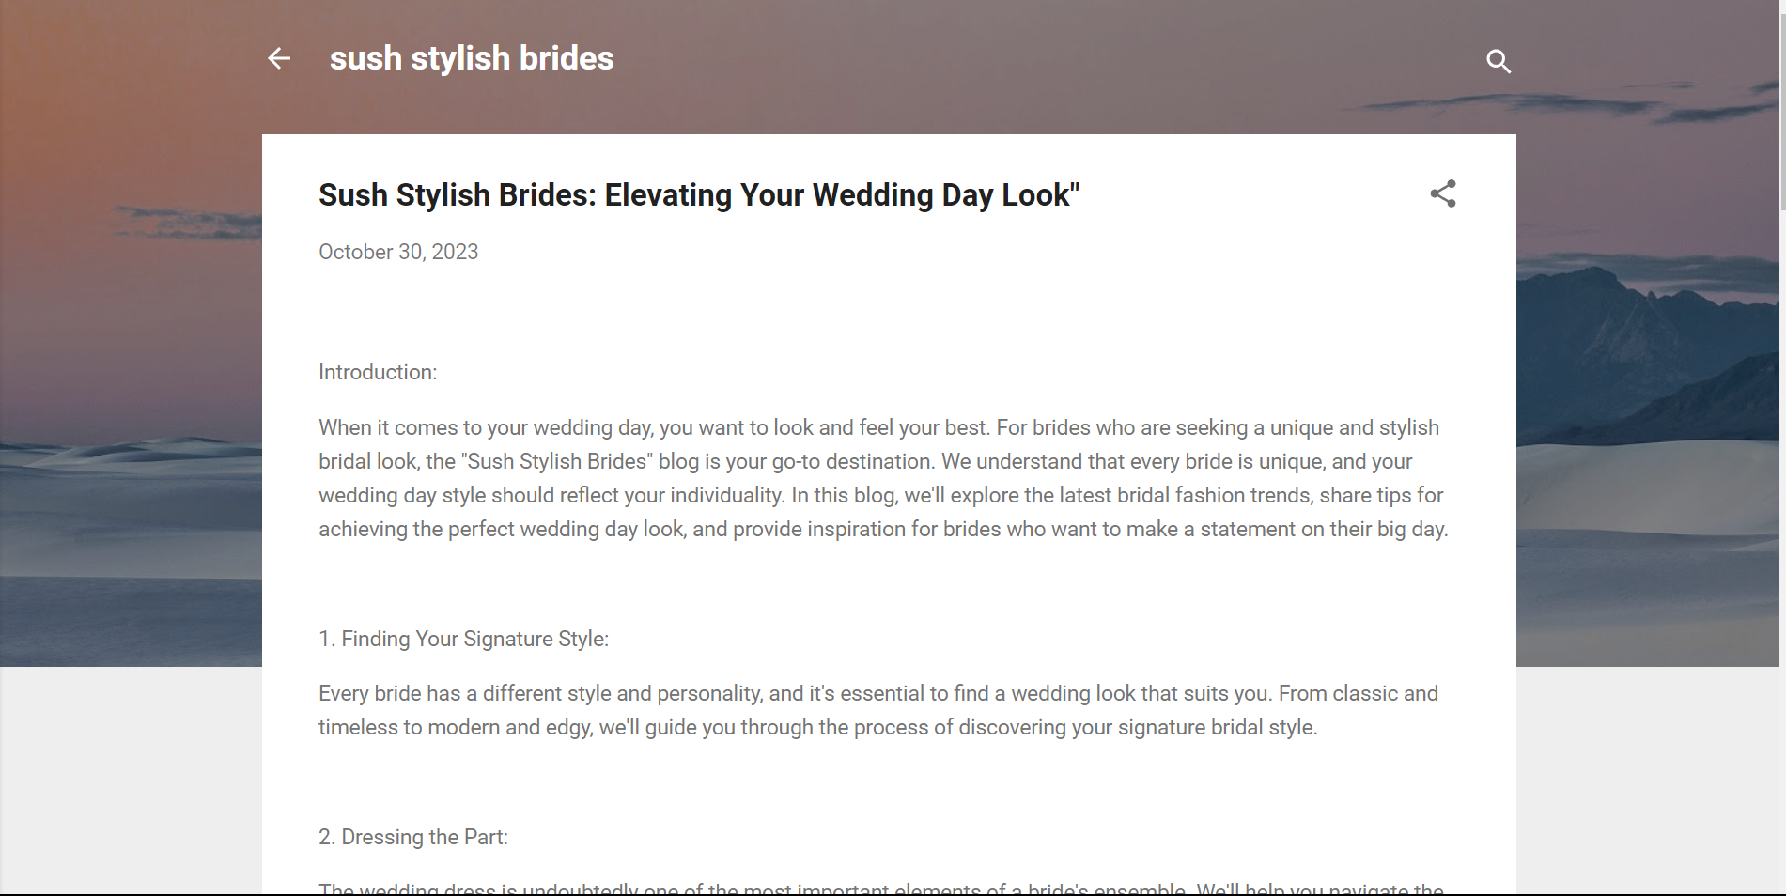

**Assignment-3:**

Create a Facebook account for your company

Facebook ID: <https://www.facebook.com/61553083464383/posts/pfbid0fZehpHzyK8u4x8B5Gw7yZyYLdamc79MytakmLLQYFJErD2ryULMSFBNbwtCqVWYGl/?app=fbl>

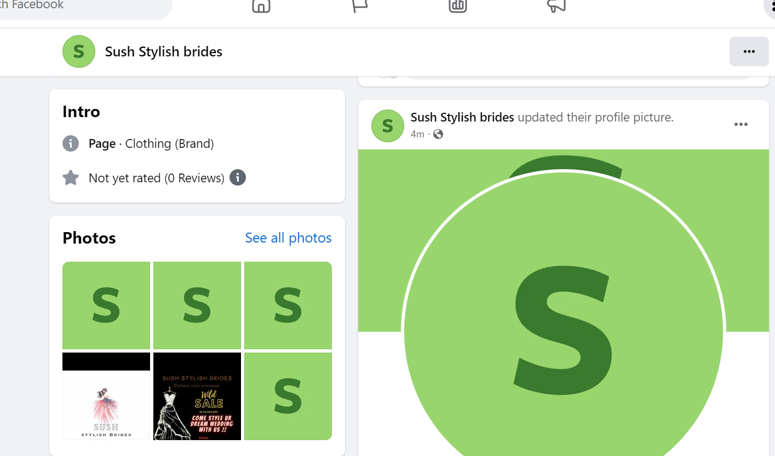

**Assignment-4:**

Create an Email Newsletter for your company and post it in your company blog site. Do google analytics for you blog and send google analytics id.

Google Analytics ID: G-49PL97XYDR

Email Newsletter link:<https://sushstylishbride.blogspot.com/>

Email Newsletter:

